ECE 682 X
Senior Design Project:
Digital Stimulus / Monitor Unit

Autumn 2006
The Ohio State University

Group Members:
Patrick Andrasko, Brian Burch, Mohammad Habib, Ibrahim Isleem, Amanuel Lemma, Paul Schnapp, Yen-Ting (Eddie) Shen, Ben Toth, Nguyen Truong, Randy Uebel, Alaeddin Yousef,

Introduction 3
Overview 3
Description 3
Specifications Requested 3
Specifications Met 3
Hardware 4
Principles of Operation 4
Main Controller 5
Timer Chips 6
System Clock 6
USB Communications 6
System Power 6
I/O 6
Hardware Components 7
Discrete Components 7
ICs 7
Enclosure 9
Circuit Board 10
Software 12
PC 12
Backend 12
GUI 15
PC to USB Interface 17
PIC 17
Cost analysis 17
Environmental Constraints 18
Results 18

Introduction

Overview
This document discusses a Digital Stimulus/Monitor Unit (DSMU) designed for the Senior Design Project course (call-no. ECE682X) at The Ohio State University. Details of the specifications, design, and fabrication of the unit are covered in detail. For operation instructions see the accompanying Users Manual.

Description
The function of the DSMU is to act as a digital signal interrogator and exciter for testing digital circuitry. The original specifications requested for the unit were not met. We therefore discuss both the specifications required and those actually met.

Specifications Requested
The functionality required of this unit is as follows:
- I/O
  - Eight channels of I/O
    - 3 dedicated inputs
    - 2 bi-directional input/outputs
    - 3 dedicated outputs
  - 0-5V I/O operation voltage
- Maximum sampled frequency of 5 MHz
- Communication with a PC via (high-speed) USB 2.0 link
- Operation on a Windows XP PC
- Display of data in a graphical user interface (GUI)

Its function is to take inputs signals from the Device Under Test (DUT) and output the data in a graphical interface on a PC. It was also required that the unit simultaneously generate outputs to be configured by the user using the PC software.

Specifications Met
The required specifications were met except for the maximum frequency. The required frequency was 5 MHz but since our timer chips were running at 12 MHz, the reading frequency was then 4 MHz for each of the counters (due to time lost doing instruction transfers). Since we have 8 channels to read, the frequency was divided by 8. As a result the sampling frequency became 500 KHz. This limited our unit’s ability to read a maximum frequency signal of 250 KHz.
Our unit has 3 Input and 3 Output Channels and 2 Configurable Input/Output Channels. The Output voltage is 0 to 5 Volts. The unit can be connected to a PC via USB port. This USB connection is only a Full-Speed connection, and not the High-Speed specified in the requirements.
Simple user-friendly software was developed using C# which can be executed on any PC running the Windows XP Operating System. Since the unit is 5 by 3 inches it is portable and light about .35 lbs. It could also powered by the USB connection alone. The total cost used in this class was about $118 since extra components were bought to save time instead of ordering new ones when wrecked, but for a mass production the cost will be less than $75 per unit.

Hardware
The block diagram in Figure 1 models components of the hardware in the DSMU. Each component is discussed in detail in the following sections.

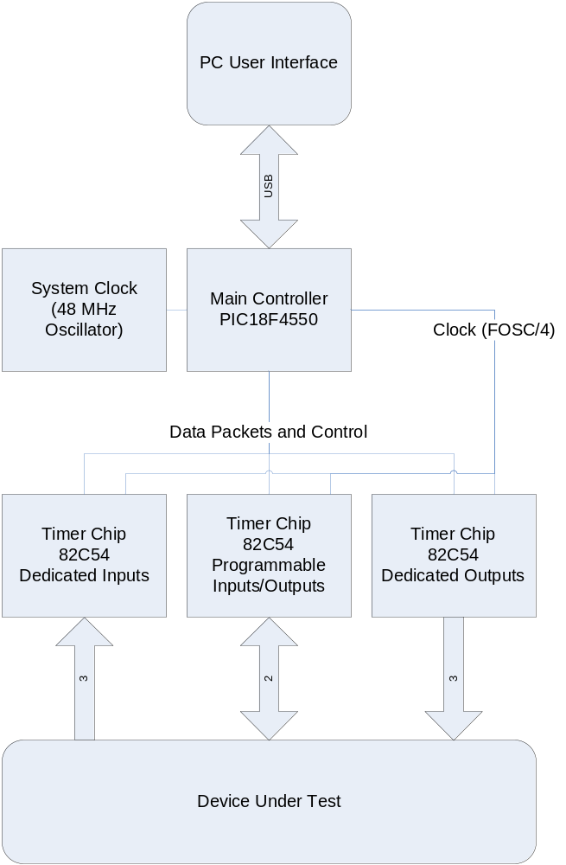

Figure 1: Hardware Block Diagram

Principles of Operation
This system was designed to distribute the load throughout the hardware components. The system consists mainly of the Main Controller and three Timer Chips. The schematic (Figure 2) of the block diagram above (Figure 1) show the wiring connections between each of these chips.
The DSMU was designed to be a portable field unit. Thus some of the design decisions were made with this in mind. Some of the aspects considered in this light were the minimization of components used, minimal power consumption and weight.

Each block component is discussed in detail in this section.

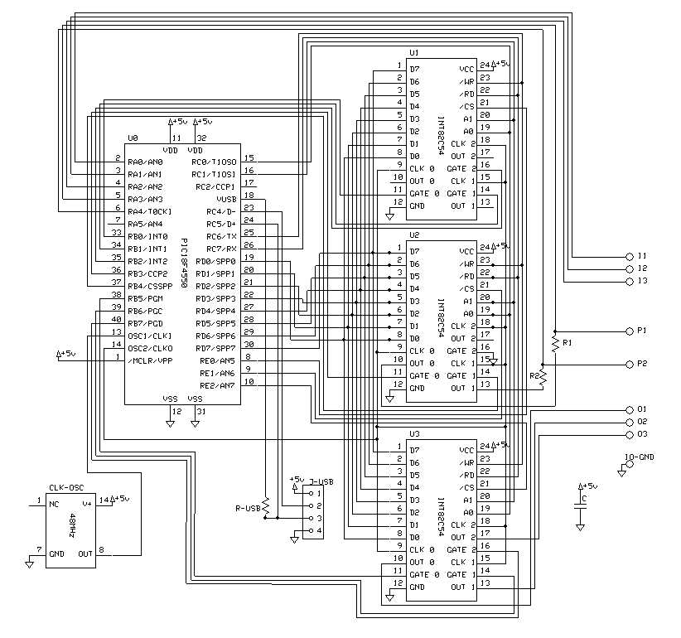
Figure 2: Circuit Schematic of the DSMU

Main Controller
The main controller is the coordinator of the system. It receives instructions from the USB connection with the PC and then uses that data to setup the appropriate timer modes in the timer chips. While the timers are running, it buffers the waveform data from each and then sends this data back to the PC via the USB.
The controller is also in charge of the inputs. The inputs are given to the main controller directly, and the controller then clocks each using dedicated input timer modules on one of the timer chips. This is done this way to free the PIC from a single task so it can get data from all the timer modules without having to focus on inputs or outputs only.
Inputs require the PIC reset the input timers on every edge transition, since the timers only time from the rising edge to the falling edge of the timer input. Thus on every external input transition, the timers are reset and the timer inputs are enabled again.

Timer Chips
Each timer chip has 6 modes (discussed in detail in Hardware Components). These chips were used so that inputs and outputs could be concurrently sampled and generated. The main processor alone does not have the capability to multi-task in this way. Each timer chip has three internal timers. Thus a total of three timer chips were needed for this project, to provide the necessary input/outputs.

System Clock
The clock-oscillator in the unit is a 48 MHz oscillator. It connects directly to the main processor. The three timer chips all require a 12 MHz clock input, which is taken from the clock-output of the main processor, which is the input clock (i.e. 48 MHz) divided by four (i.e. 12 MHz).

USB Communications
The DSMU unit communicates with the host PC via USB. There is a USB 2.0 Full-Speed (12 Mbps) transceiver in the Main Controller, which is connected to USB Type-B Female connector. For more information on communication between the PC and PIC see the Software PIC section.

System Power
Power is delivered to the system via the USB connection. This connection is capable of 500 mA at 5 V.

I/O
There are three dedicated inputs, two programmable input/outputs, and three dedicated outputs. All inputs expect a +5 V logic HI and 0 V logic LO. Outputs generate a +5 V logic HI and 0 V logic LO. These are the same voltages as those provided by the power from the USB connection.

Dedicated Inputs
These inputs are routed through the Main Controller which then clocks the time between transition edges using the timer chip dedicated to input timing.

Programmable Input/Outputs
The programmable input/outputs are configured before every run. These are wired in a similar fashion to the dedicated inputs, but they also have a resistor tying them to the outputs as well. The resistors allow the chips to function in either input or output mode. Resistors were used because they would work, and would also save board space and component usage (costs).

Dedicated Outputs
The outputs are taken directly from their respective timer chips. These outputs are read by the processor through the timer chip using instructions, not from the output pins directly.

Hardware Components

Discrete Components
Table 1 holds a list of discrete circuit components and their quantities in this unit.

Component Type | Quantity
10 kΩ Resistor | 2
1.5 kΩ Resistor | 1
1 pF Capacitor | 1
Female USB Type-B Connector | 1
48 MHz Clock-Oscillator (14-pin DIP) | 1
PIC18F4550 | 1
Intersil 82C54 | 3
Table 1: Discrete parts list

ICs
- Main Controller (PIC18F4550)
- Three timer chips (Intersil 82C54)

Main Controller
The PIC18F4550 was used because it has an integrated USB transceiver, as well as enough I/O ports to meet the requirements for controlling the timer chips. This IC is in charge of buffering data to send back to the host PC, initializing and controlling the timer chips, as well as gathering inputs (See Principles of Operation for more details on input timing). The programming aspect of this controller is discussed in the Software PIC section.
For more details on this component, see the accompanying documentation PDF (PIC18F4550.pdf).

Timer Chips
Each timer chip contains three internal timer modules. These modules are used to find the difference between input/output edges (delta time) for inputs, or generate outputs. These chips have six modes of operation:
For more details on this component, see the accompanying documentation PDF (Intersil82C54.pdf)
Mode 0 - Interrupt on Terminal Count: Mode 0 is typically used for event counting. After the Control Word is written, OUT is initially low, and will remain low until the Counter reaches zero. OUT then goes high and remains high until a new count or a new Mode 0 Control Word is written to the Counter.

NOTE: Inputs use these timers in Mode 0. The timers in Mode 0 only generate delta times from positive to negative edges. Because of this, the inputs are routed through the main controller, which enables/disables the timer chips as needed in order to clock the delta time. The controller will clock on one edge, stop on the next, reset the timer and begin timing again. Thus, each time the input transitions states, the corresponding input timer is reset and the delta taken again.

Mode 1 - Hardware Retriggerable One-Shot: OUT will be initially high. OUT will go low on the CLK pulse following a trigger to begin the one-shot pulse, and will remain low until the Counter reaches zero. OUT will then go high and remain high until the CLK pulse after the next trigger. Mode 1 is non-periodic.
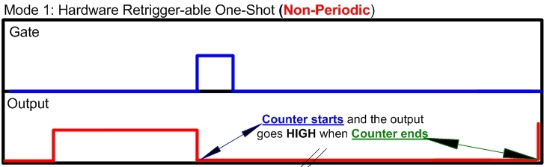

Figure 3: Timer chip Mode 1 timing diagram

Mode 2 - Rate Generator: This Mode functions like a divide-by-N counter. It is typically used to generate a Real Time Clock Interrupt. OUT will initially be high. When the initial count has decremented to 1, OUT goes low for one CLK pulse. OUT then goes high again, the Counter reloads the initial count and the process is repeated. Mode 2 is periodic; the same sequence is repeated indefinitely. For an initial count of N, the sequence repeats every N CLK cycles. Mode 2 is periodic.

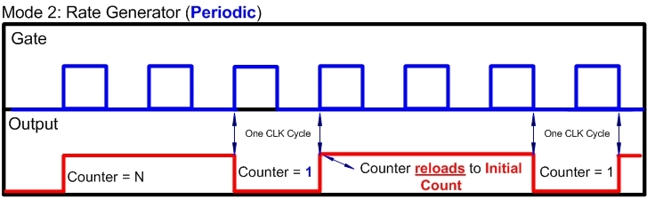

Figure 4: Timer chip Mode 2 timing diagram

Mode 3 - Square Wave Mode : Mode 3 is typically used for Baud rate generation. Mode 3 is similar to Mode 2 except for the duty cycle of OUT. OUT will initially be high. When half the initial count has expired, OUT goes low for the remainder of the count. Mode 3 is periodic; the sequence above is repeated indefinitely. An initial count of N results in a square wave with a period of N CLK cycles. Mode 3 is periodic.
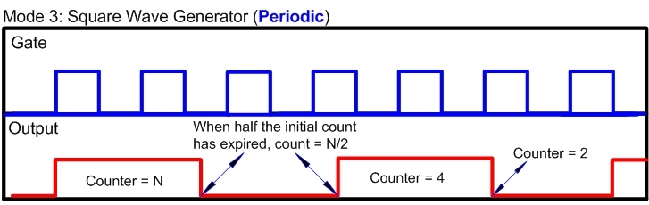

Figure 5: Timer chip Mode 3 timing diagram

Mode 4 - Software Triggered Mode: OUT will be initially high. When the initial count expires, OUT will go low for one CLK pulse then go high again. The counting sequence is “Triggered” by writing the initial count. Mode 4 is non-periodic.

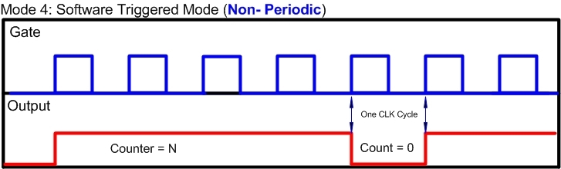

Figure 6: Timer chip Mode 4 timing diagram

Mode 5 - Hardware Triggered Strobe (Retriggerable): OUT will initially be high. Counting is triggered by a rising edge of GATE. When the initial count has expired, OUT will go low for one CLK pulse and then go high again. Mode 5 is non-periodic.

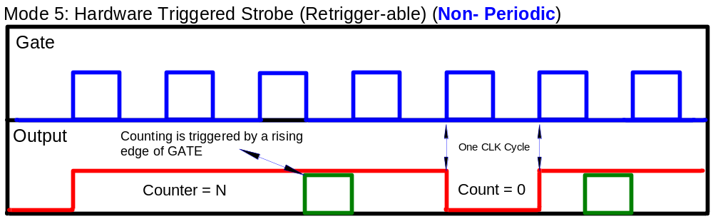

Figure 7: Timer chip Mode 5 timing diagram

Enclosure
The enclosure for the DSMU is built from acrylic plastic sheets. The use of the acrylic sheets allowed the unit’s interior to be displayed. The top of the enclosure has an operable cover that enables access to the unit components such as the PIC (main processor) and the circuit board. As a result, it will be easier to replace components and hook up wires to the connectors when necessary.
The acrylic sheets were carefully measured to properly contain the DSMU circuit board. Due to the fact that the acrylic sheets were fragile and to attain maximum precision, the material was cautiously cut into the appropriate pieces with an electric power saw. As a result of the fragility, the connectors were placed on the “lid” at the top of the enclosure. Since the “lid” was not directly connected to the rest of the enclosure, this ensured that there was no damage to the enclosure as a whole and that the acrylic sheet used for the “lid” can be replaced with a new sheet if necessary. At the bottom of the enclosure, three holes were drilled to allow the circuit board inside the unit to be securely fastened.
Once the acrylic sheets were cut into the appropriate pieces, each newly cut sheet was used on a grinder to smooth out the rough spots on the material. Finally, sealant glue was used to put the pieces together to form the enclosure. The final dimensions for the enclosure are 5 x 10 x 6 centimeters.

Circuit Board
The circuit board for this unit (Figure 8) was designed using software available from ExpressPCB. The two-layer board was then manufactured by ExpressPCB and shipped to us. The “3 boards for $51” deal was used (with $9 shipping) which is ~$20 per board. This price is expected to be lower for production units. The board measures 2.5” by 3.8”.
The PC-Board layout file (schematic.pcb) accompanies this documentation. Figure 8 (A-D) shows the different layers of the board, and the placement of components.
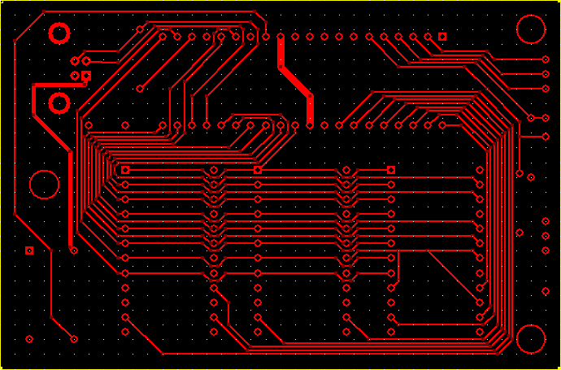
Figure 8 (A): Top layer, top view

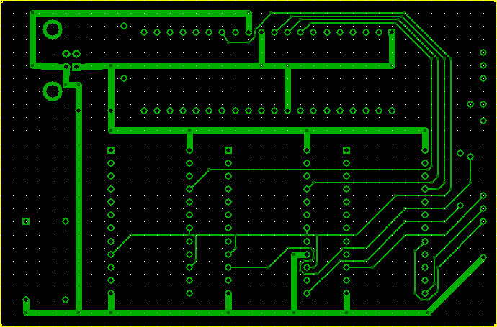
Figure 8 (B): Bottom layer, top view

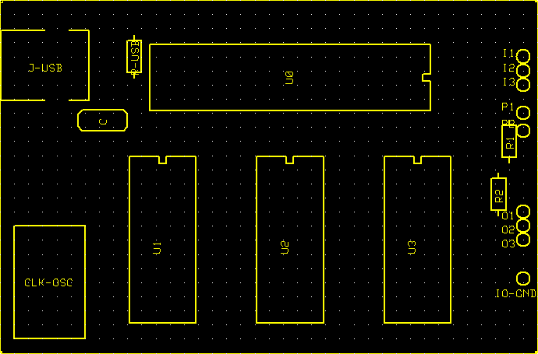
Figure 8 (C): Component placement, top view

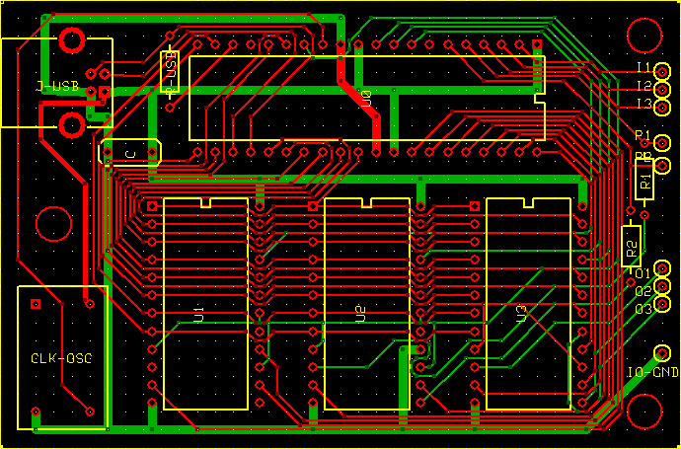
Figure 8 (D): Composite top view

Software
This section discusses all aspects of data flow (Figure 9) through the software, and each software component.

PC
The PC side of the software consists of two parts: a backend and a GUI. The backend is responsible for getting data from the USB transfer and sending commands to the DSMU, while the GUI is responsible for displaying data received from the transfer and getting commands from the user. The structure of the PC code is diagramed in Figure 10.

Backend
All the PC code works on the basis of threading. The MainForm is on one thread started by the user. The MainForm then starts another thread to run the DSMUController. This allows for independent operation of the GUI and the USB controller. If there were no threading then every time something had to be written to or read from USB the GUI would freeze.
Since these are on two different threads messaging between the two is event based. When the DSMU gets a bit of data from the USB port it puts the information into an instance of the TestEventArgs class. This is made into an event and sent up to the MainForm. OnTestEvent() will receive this and send it to OnResponseHandler(). When the main form receives the event it starts another thread to handle this event. This thread will decide what type of event this is (a data event, or an end of run event). If it is a data event it will store the data in the corresponding channel and end. If it is an end of run event it will set the GUI into stopped mode.

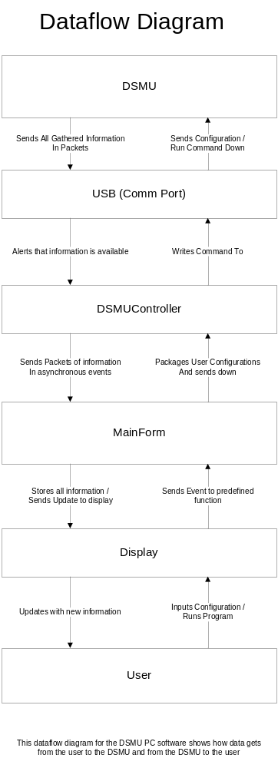
Figure 9: Dataflow through software
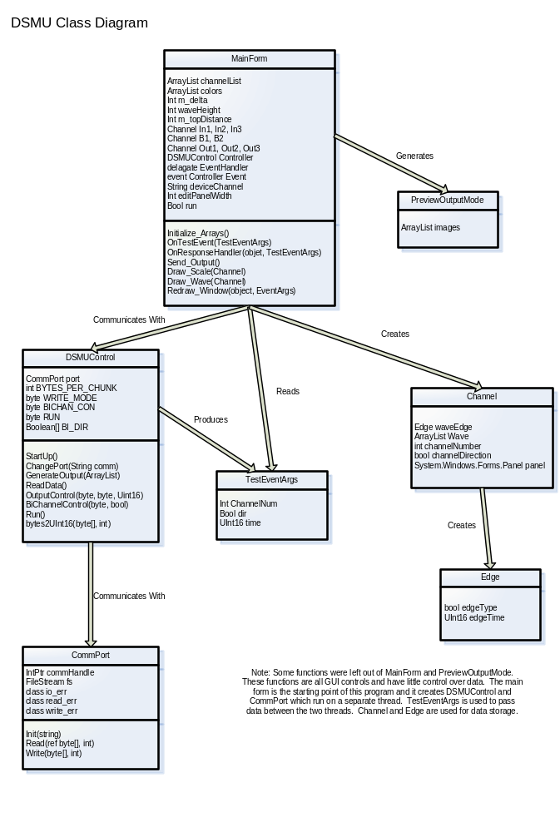
Figure 10: PC side class diagram

Running
When the user clicks the run button a series of events happen. First of all, all of the bi-directional channels are polled to determine their orientation. Then all of the channels set to output are polled to gather information like chip mode to be sent down to the DSMU. If any of the information is erroneous (if the user put text into the n number box) the GUI will throw an exception. This exception will alert the user to the problem and ask them to fix it. The way this is exception is thrown is through a try() catch() algorithm. All of this information will be packed into an ArrayList of ArrayLists of information by the Send_Output() function. Once all of this is packed it will be sent down to the DSMUController where it will be parsed through and sent to the DSMU.
The DSMU will run and collect all of the data in its internal memory and then when the run is over it will send all of its data up to the computer. The DSMUController will receive all of this data and send it up to the MainForm. When the data transfer has completed the DSMUContoller will send an end-of-run event to the MainForm so that the GUI can refresh with the new data.

Channels and Edges
All of the information for the channels are kept in Channel classes. These classes are data classes and don’t have much functionality to themselves. This is due to the fact that they are mostly controlling data that is used by different threads and having these classes control their own functionality would be almost impossible. The Channel class holds an ArrayList of Edges called Wave. This is a public data member to make it easier to be read through by the grapher. The Channel class also has some basic information like channel number, channel direction, and the channel panel (see GUI).
The Edge class is a very basic data class that contains only the edge type and time. This is just like an (X,Y) point for a graph.

GUI
The way that .Net sets up all the GUI functions is also based on threading and events. Whenever a button is pressed or slider is moved an event is sent to the code and the pre-defined function is called. All of the button pressing, scrolling, mouse-clicking, etc. is set up in this manner on the GUI.
The actual GUI is set up in a table of panels. Each channel has a table row consisting of two columns. The first column is the identifier column that shows the channel name and is home to a limited number of channel options (changing the I/O on the Bi-Directional channels, and editing the waves on all the channels set as outputs). The second column in each channel’s row is the wave view and editing panel. This panel is actually a panel inside another panel. The reason this is done is for scrolling. The table does not allow for individual cell scrolling so panels have to be used to all for the waveforms to exceed one screen. Since each channel has it’s own panel all of this information is kept inside the Channel object. Also, the channelList ArrayList will keep track of all the available channels. This is set up in the initialize_Arrays() function that is called by the constructor.
On the input channels this panel is simple. This panel will show the waveform and the scale and that’s it. On the bi-directional and output channels, however, the waveform editing view has to be available to the user. Any output channel will be initially set to the wave edit view since the user has to define what output wave they want for a wave to be actually sent out. In this view the user can choose which timer chip mode they would wish to use (there is an explanation of this in the hardware section and the user manual), what n they would like if applicable (only two timer chip modes require an n), and a preview output window. The preview output window instantiates a new form that allows the user to browse through a graphical representation of what the different timer chip modes do.
Once the “Done” button is clicked in the wave edit view the waveform view will be toggle on. After a run is preformed this will show the user what waveform was actually sent out by the DSMU.
Note that the only time that the mode and n of an output channel is sent down to the DSMU is when the user clicks the “Run” button. The device channel however will be sent down whenever the user changes it with the numericUpDownBox.

Graphing
Since this is an oscilloscope type display a lot of graphing is done. The way that the graphing is handled is though the Graphics object and a Pen. The Pen controls the color, thickness, and line time of the drawing. The redraw_Window function will loop through all of the channels that are in the waveform view and draw the scales and waveforms of each.

Scale
The first thing to be graphed is the scale of the output waveform. This scale is just an array of vertical lines drawn throughout the length of an individual panel. The actual size of the scale is controlled by a global variable in the MainForm called m_delta. This variable represents how many lines will be shown in a single window length of the panel. In other words it is the number of lines that the user can actually see at one time.
Since the GUI is using a zoom in and zoom out feature the scale will get really crowded on the screen if the user decides to zoom out too far. This is where the sub_scale variable comes into play. Once the user zooms out to the point where they can see 75 lines in the window the subscale will start showing every other scale line.
Once the scaling factor has been computed a “for loop” will draw all the lines in the panel. Note this is for the entire panel and not just for the visible part.
To make the scale easier to read a number is drawn iteratively throughout the scale lines. This number, like the scale, will appear less the father the user has zoomed out.

Waveform Graphing
Once the scale has been drawn on the panel the waveform is just drawn over it. This is using the same technique with the Graphics object and a Pen. To make the window easier to look at each waveform is graphed in a different color. These colors come from an ArrayList called colors that is initiated by the initialize_Arrays() function that is called from the constructor. If the colors ever need to be changed just change the colors that initialize_Arrays() puts into the ArrayList. The waveform graphing is a little more complicated than the scale graphing but that is only due to the fact that it has to draw lines with different orientations.
The wave ArrayList in the Channel object contains almost all the information needed to graph each waveform. Based on the time and type of each Edge in the ArrayList the function will graph the appropriate wave. Because the Edges coming in from the DSMU are event based this is done through taking the difference of each adjacent point. Basically the wave is graphed one “event” at a time.
The other information needed to graph these waves are the wave height and distance from the top of the panel. This information is stored in global variables called m_waveHeight and m_topDistance.
Note that the entire wave is graphed even though it can’t always fit into the panel view. This is why there needs to be scrolling. Every time the user scrolls a panel that panel has to be redrawn. The drawing algorithm used will make sure that the appropriate portion of the waveform is always in view.

Saving a Run
The GUI has a saving function that will output a text file of the current state of the program. Each Channel will list its name, I/O state, and waveform. Then the program will iterate through the waves for each channel and output the (x,y) points in a list. This is done through a FileStream and a StreamWriter. To mark the file the current DateTime is written at the top.

PC to USB Interface
Since this project was under time constraints high-speed USB 2.0 could not be realized in the software. A custom USB driver would have been needed to make this connection. Because of this the USB was masked as a COMM Port from the software’s point of view. A standard set of Windows XP files takes care of this for us. The files usbscr.sys and ccport.sys, which come with every XP system, allow us to effectively treat USB as a COMM Port and do standard reads and writes to it as if it were a COMM Port. This made the speed go down considerably but the ease of use go up considerably. All of this is taken care of by the CommPort class. This serves as a layer of abstraction between DSMUControl and the USB.

PIC
The basic function of the PIC microcontroller code is that of obtaining, processing and relaying information to the rest of the system. It is the first step in the process of analysis of a DUT by our unit. The code for this was written in the C language since we felt it would be easiest for all PIC programmers on the design team to work on the project.
Through the help of Microchip’s documentation on migrating from RS-232 to USB, we are able to simply transfer data as previously mentioned. USB UART functions within the microcontroller’s USB firmware. Data is accessed one byte at a time via its Address Pointer, then stored and relayed onward to one of three timer chips to be designated on a Chip Select pin on the chip.
The process begins by reading in a USB command when the section of code comes up from the USB bus. The value obtained for this acquisition is then stored in memory as a variable. A flag is then put up which will allow the chip to write the next incoming command to the USB bus.

Cost analysis
The overall budget allocated for this project is $150.00. This budget doesn’t include cost of labor. Table 2 shown below shows the cost of each part bought, the number of parts bought the price per unit and a total price. As can be seen, this unit takes up about half of the allotted budget.

Part | Number Required | Price per Unit ($) | Cost ($)
USB PIC18F4550 | 1 | 5.00 | 5.00
CMOS Programmable  Interval Timer 82C54 | 3 | 6.00 | 18.00
Project Enclosure | 1 | 5.00 | 5.00
Circuit Board | 1 | 20.00 | 20.00
3 foot USB Cable | 1 | 2.00 | 2.00
USB B Connector | 1 | 0.50 | 0.50
BNC Connector | 8 | 1.00 | 8.00
BNC Jack | 8 | 1.00 | 8.00
Resistors (Assorted) | 3 | 0.30 | 0.90
Capacitors | 6 | 0.30 | 1.80
Total |  |  | 77.30
Table 2: Budget use

Environmental Constraints
In recent years we have seen the rapid advancement on digital devices and the growth of this market has motivated to develop this device. No research has been done about the effects on Environment. However, we believe this device doesn’t have a serious health problem issue like many other electronic devices. The device will have mostly positive effects on most of the issues related with digital signal monitoring issues and will clearly be an asset to Ohio State ECE department.

Results
Section to be written.

