ECE 683 Project Description

It is desired to place a LCD TV in an entertainment highboy. The manufacturer of the LCD recommends that the unit have 3 inches of open area above the TV for ventilation. The picture below shows the TV in the highboy and needless to say, there is only clearance of ~1” at the top. This is less than the manufacturer recommends.

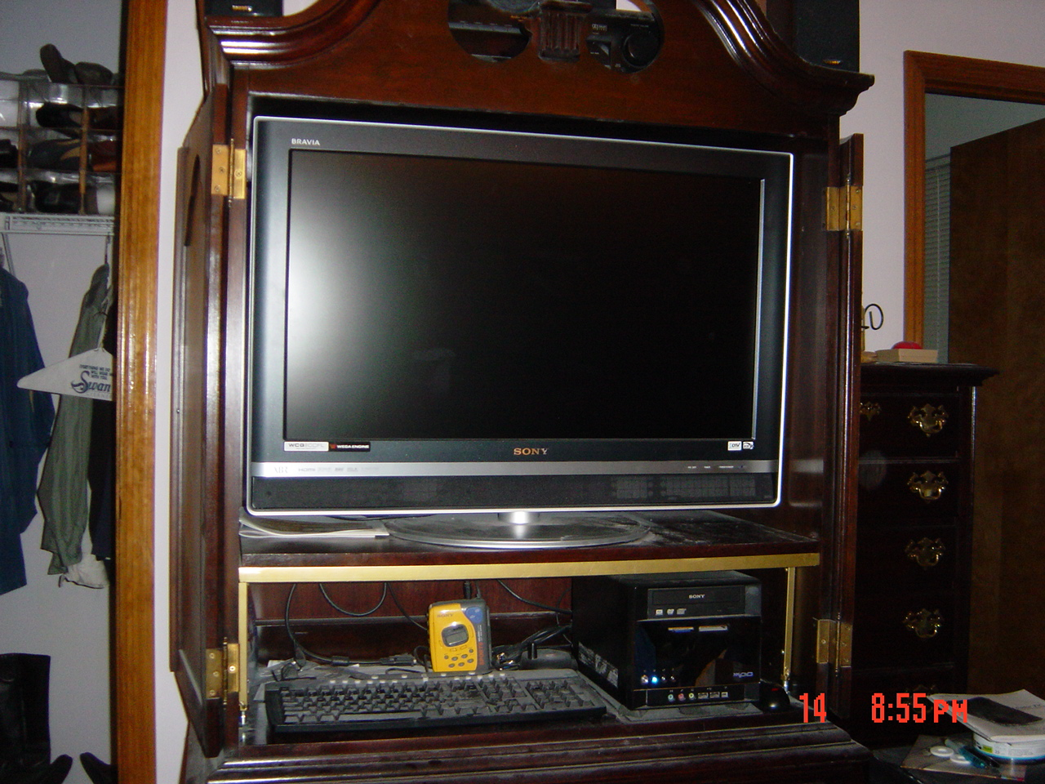

Entertainment Highboy with TV and PC

To address this issue it is desired to use some temperature monitoring thermistors that would be mounted to the inside top of the highboy and on the outside rear. This would allow monitoring of the temperature in regions that are of interest.

Additionally some DC fan would be mounted to the back of the television to do a forced air cooling. In most instances they would only have to get the air moving. The speed of the fans would be related to the temperature. At 65º it is projected that the fans could be run at 10 to 15% of their full voltage speed. The back of the television is shown in the second picture and it show that there are to cooling vent openings that the fans could be mounted near to do the ventilation.

Having the temperature sensors allows increasing the speed of the fans to say 20% at 70 º, and perhaps 40% at 85 º. Some experimentation with the fans and how they respond to PWM control is needed to determine the exact relationship.

A third fan could and an additional temperature sensor would be mountable in the lower portion of the highboy where the PC is to insure that area has active ventilation.

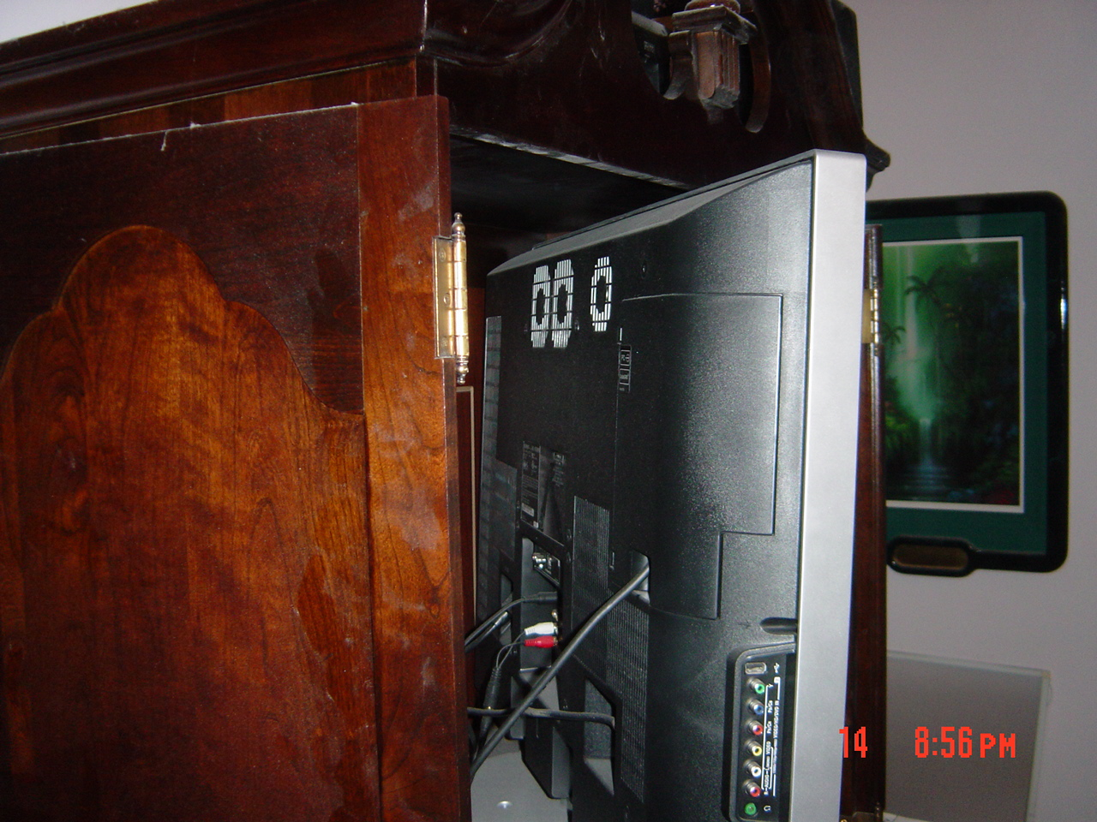

Rear of television.

The fans to be use are 12V DC fans and are on hand and will be supplied by the customer. As they are DC the are appropriately control by PWM modulation. As a brief refresher, DC motors are most efficiently speed controlled by having the DC voltage to the unit be either fully on, in this case 12V or fully off, 0V. The speed is controlled by have a square wave of an acceptable frequency, say 200Hx, and varying the duty cycle of the quare wave. To run the fan at 10% the frequency would remain the same but the duty cycle would be set to 10%. To increase the speed to 40% of maximum, the duty cycle is increased to 40%. For full speed the duty cycle is 100% or constant high.

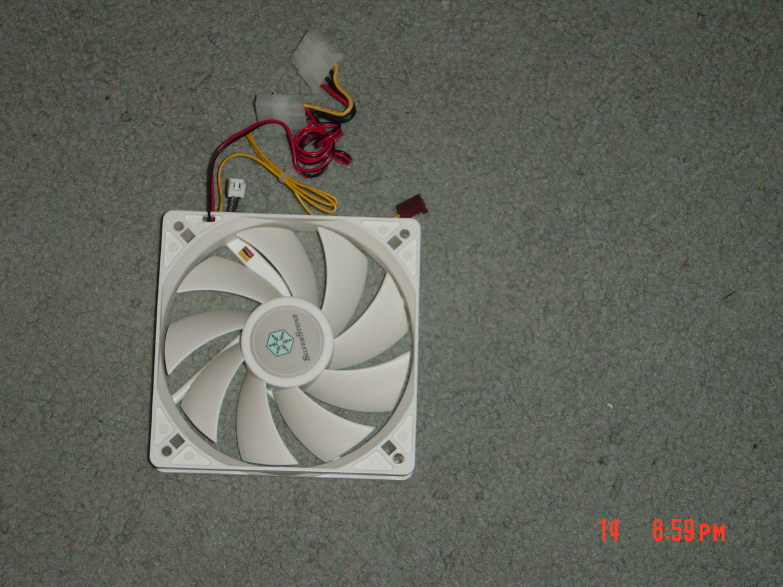

Deliverables under this project: The deliverables under this project would be a small unit that would obtain its power from a 12V DC wall AC adapter. The unit would have a mating plug for that on the adaptor. It would be housed in a small project box. It would also have appropriate connectors for 3 temperature sensors which would have 3’ of lead wire to connect back to the box. In addition there would be 3 output connectors for connecting up the fans which could be located up to 2’ away.

Besides the physical unit, detained documentation is required that would allow the customer to make changes to the software and modification to either the hardware or software once in use.

