User Manual
- SOFTWARE USER GUIDE
Software Installation and Startup
Install the software application before plugging in the Digital Stimulus Monitoring Unit.
To install the Digital Stimulus and Monitoring Unit (DSMU) software for the PC place the installation disk in a CD or DVD drive.
The installation program should automatically start running. Follow the given instructions to complete the installation.
NOTE: If the installation program does not automatically start, click on “My Computer”. Find the disk drive where the installation disk has been placed, and right click on it. From the menu that appears select “Explore”. Once the contents of the disk are displayed, double click on “Setup.exe”. The installation program will then appear as normal.
Once the software application is installed, plug the DSMU device into an available USB 2.0 capable port. A prompt will appear asking where to look for a driver for the device. When this appears, navigate to the DSMU installation disk and locate the driver file “mchpusb.inf”. This will install the necessary driver to allow USB communication to occur.
Using The Main Menu Options
File -
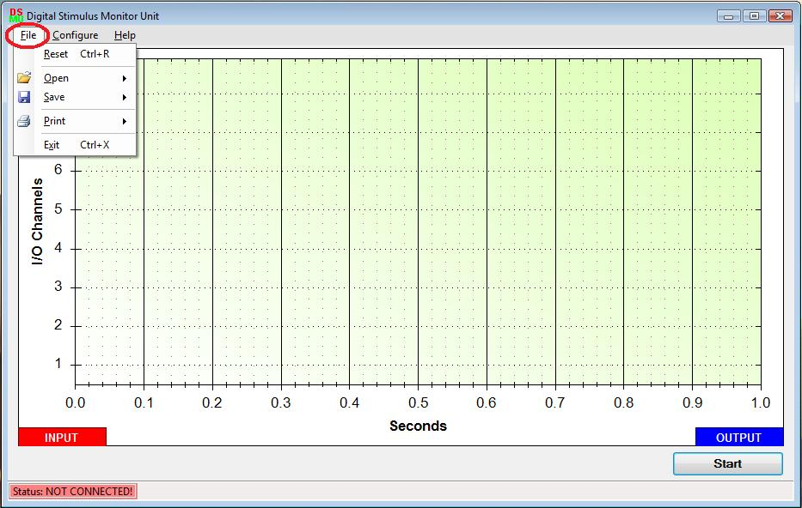
Clicking on this menu item will drop down a list of options that allow the user to do the following: -
Reset – This option will clear the graph of any data lines and also set the channel directions back to their default value (i.e. input).
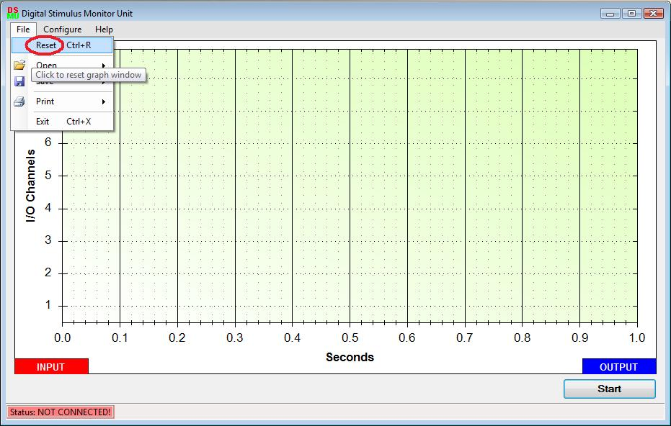
Open – This option has two sub-options
Configuration – This option will opena dialog box where the user can select a previously saved configuration file (*.cfg) to use the same configuration again.
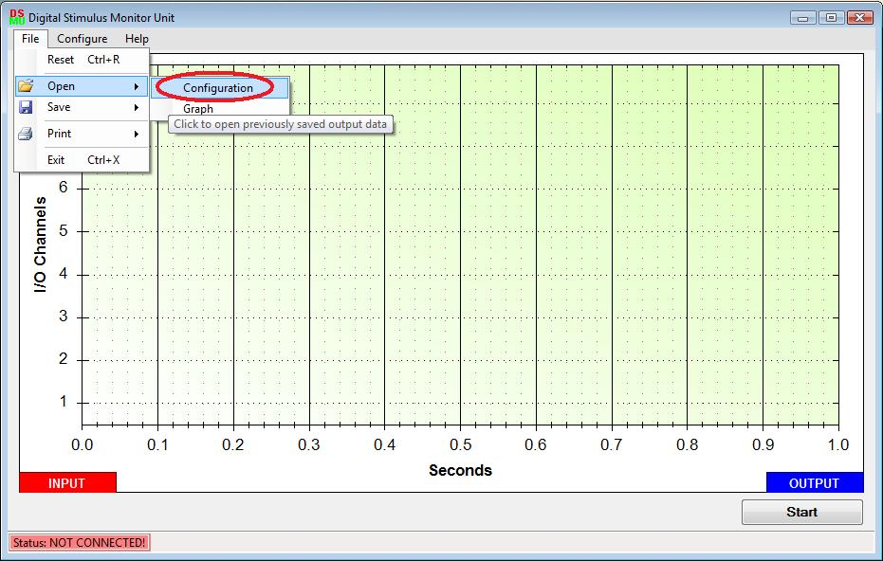
Graph – This option will open a dialog box where the user can select a previously saved graph file (*.dsmu) to view it.
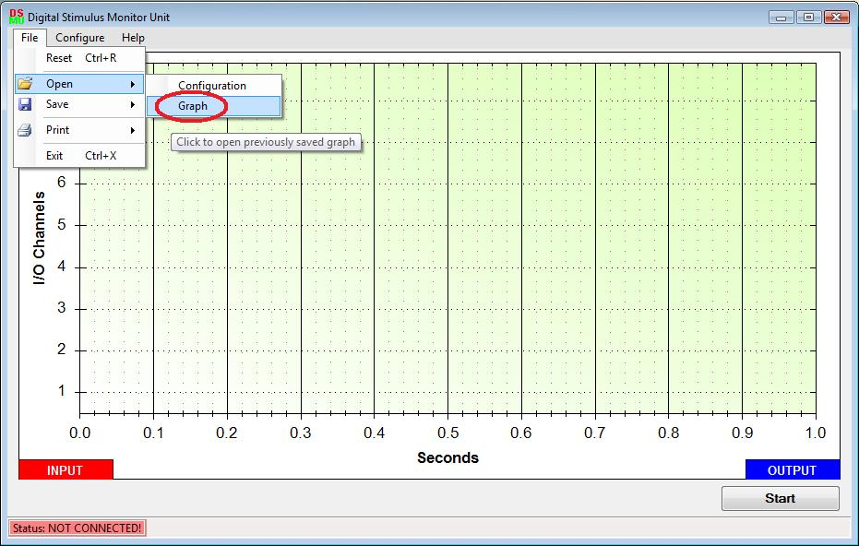
Save – This option has two sub – options –
Configuration – This option will open a dialog box, whichwill enable the user to save a configuration. A configuration file consists of channel direction selections, clocked data output fields (if any) and complex data output fields (if any). The saved file can be opened at a later time to be used again. The DSMU’s file extension for a configuration file is “.cfg’.
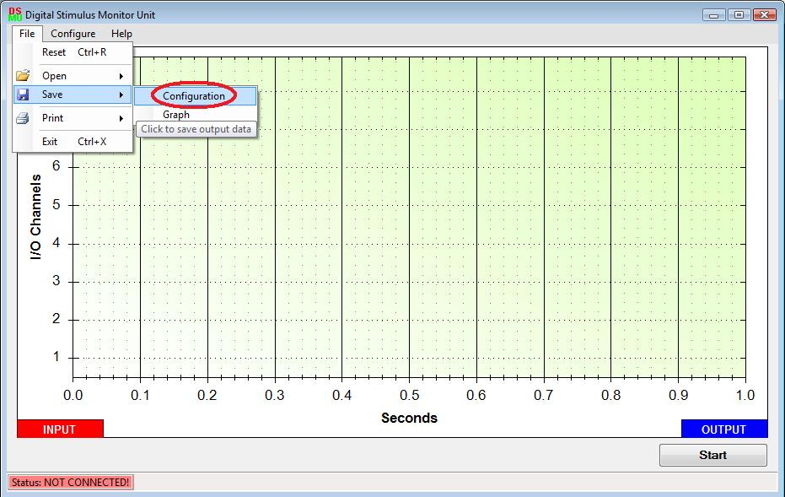
Graph – This option will open a dialog box where the user can save a graph to a file. The DSMU’s file extension for a graph file is ‘.dsmu’.
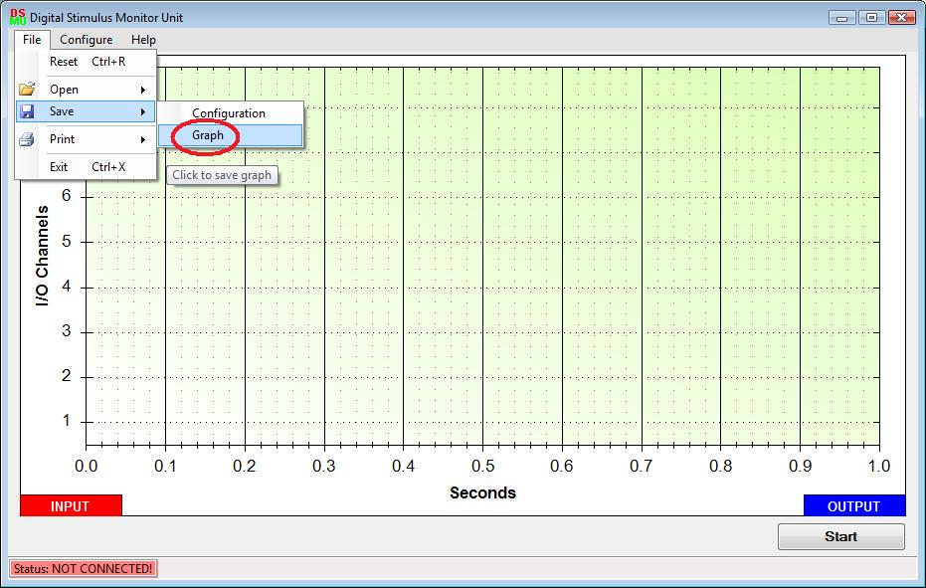
Print – This option has two sub-options –
Graph –This option will enable the user to print the current graph in the main window. A print dialog will pop-up presenting the user with numerous settings to customize their printing.
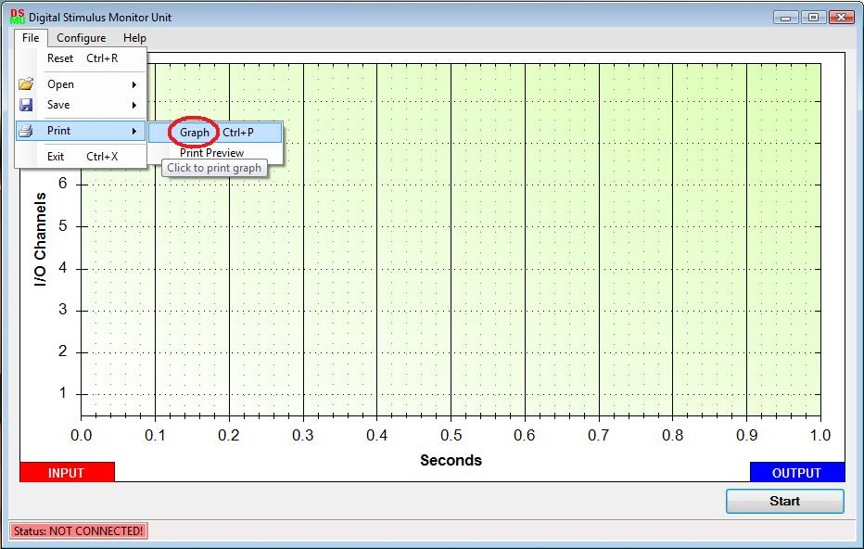
Print Preview – This option will let the user view the actual print layout before printing.
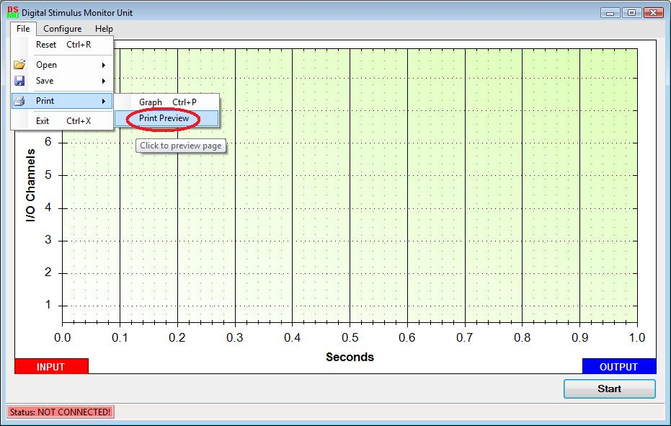
Exit –Clicking this option will exit the DSMU program.
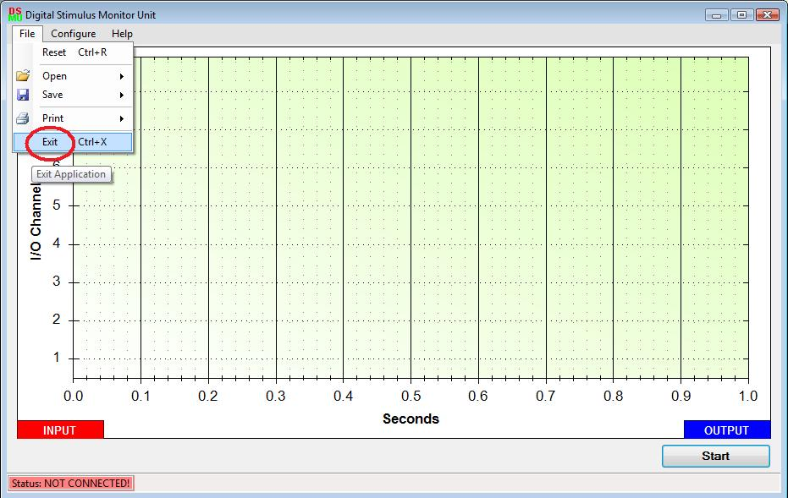
Configure –
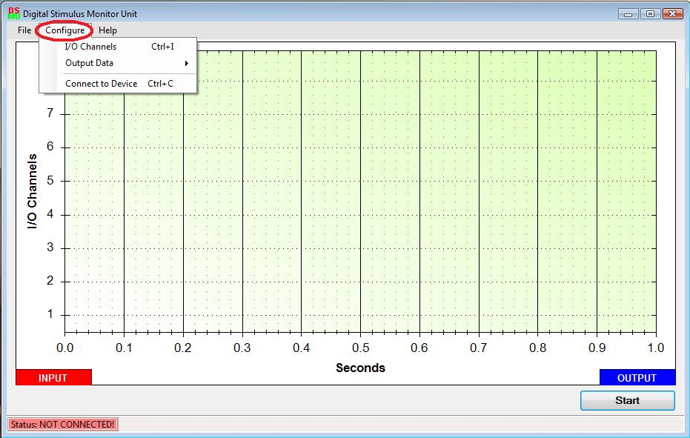
Clicking on this menu item will drop down a list of options that allow the user to do the following: -
I/O Channels – Clicking this option will open up the I/O Direction Control Window, where the user can select the data direction for the 8 ports of the DSMU. See the I/O Direction Control Window for more details.
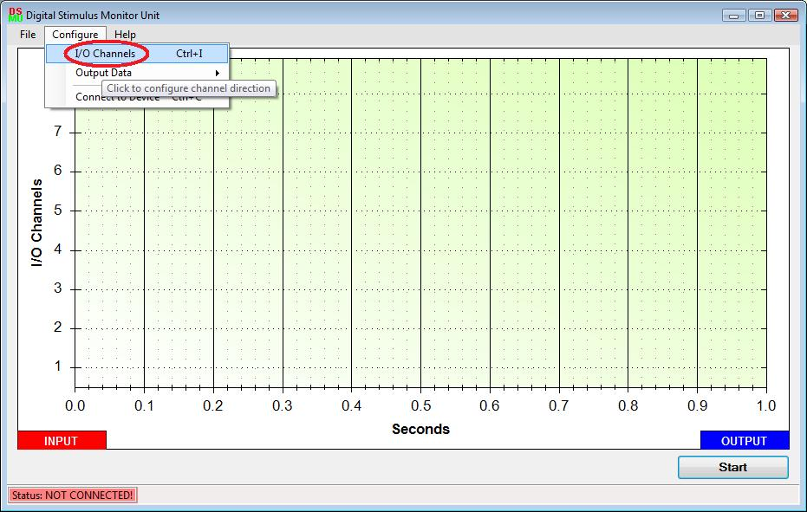

Output Data – This option has two sub-options –

1. Complex Data – Clicking this menu option will open the Complex Output Data Window, where the user can configure the complex output data to be sent out through the DSMU to an externally connected circuit. See the Complex Output Data Window for more details.
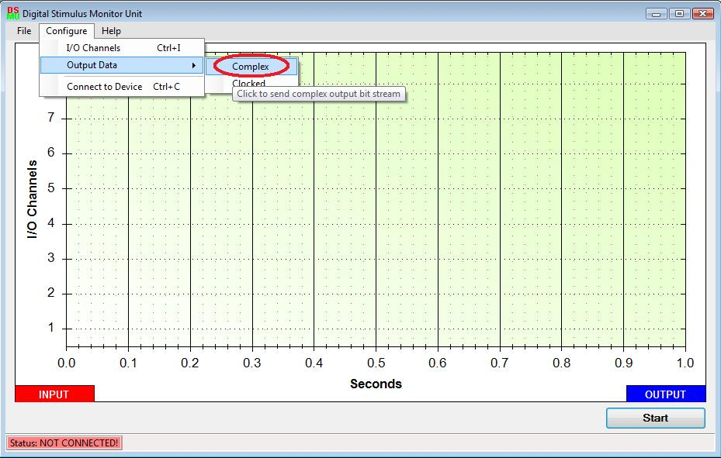
2. Clocked Data – This option will open the Clocked Output Data Window, where the user can configure the clocked output data to be sent out through the DSMU to an externally connected circuit. See the Clocked Output Data Window for further details.
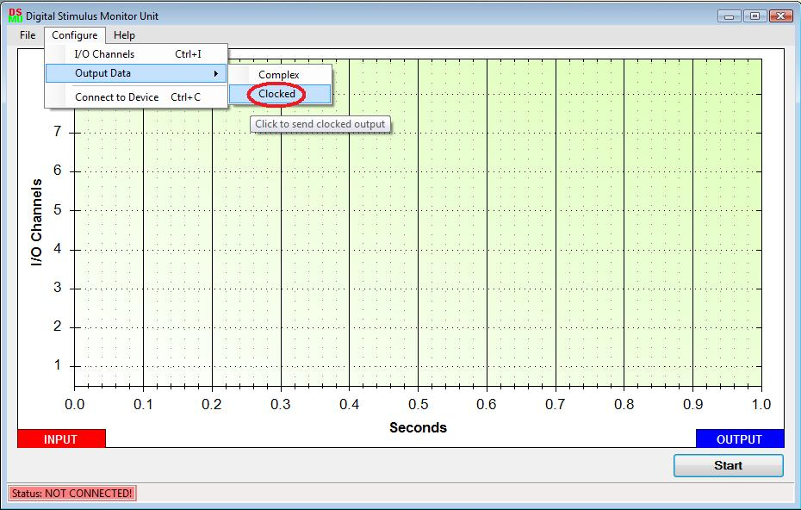
Connect to Device – Clicking this option will connect the DSMU hardware to the PC. The status of this connection is indicated in the main software window at the bottom left corner. See The Status Bar for more details.
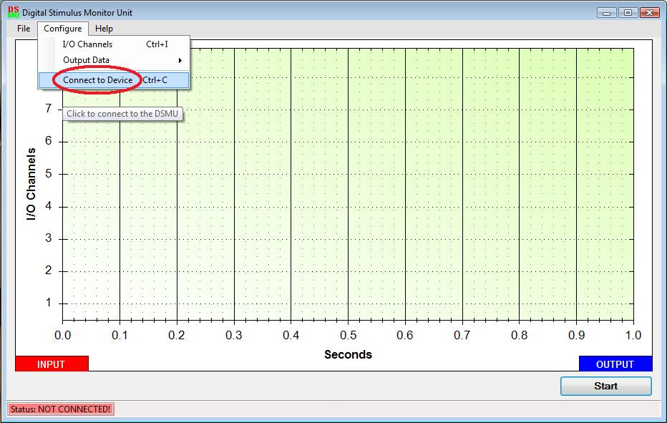
Help – This menu item has further sub-options –
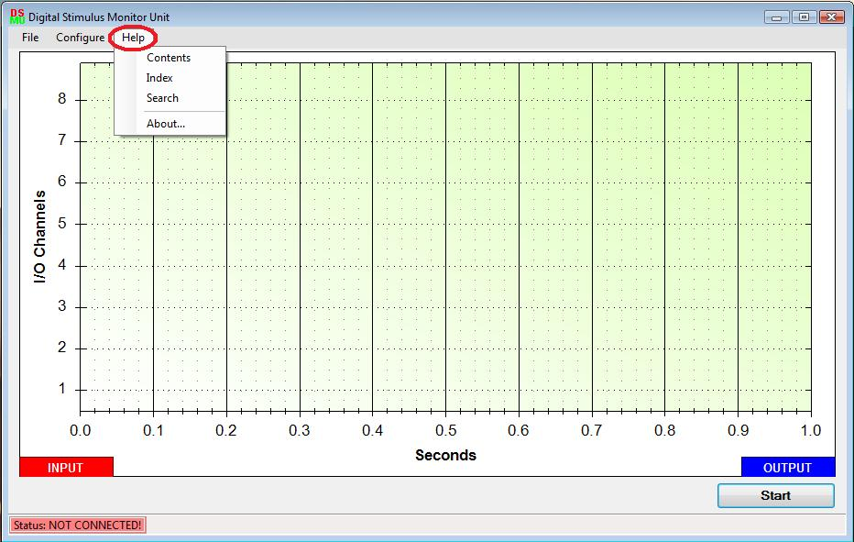
Show Help Documentation – Clicking this option will bring up a word file where the user can browse through the help files based on the content topics.
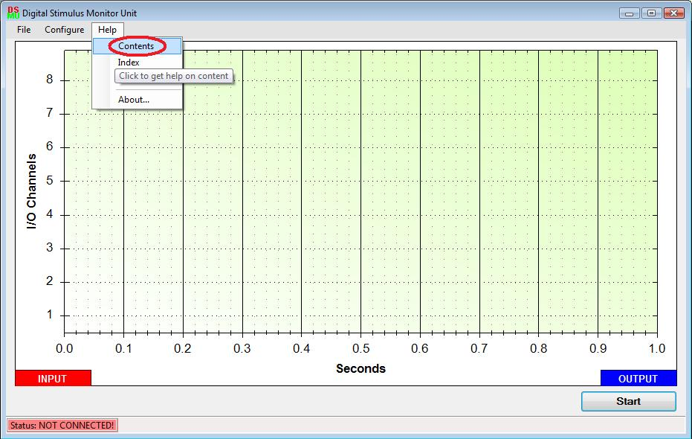
About – This option will bring up a new window which gives details about the software version, copyrights and purpose.
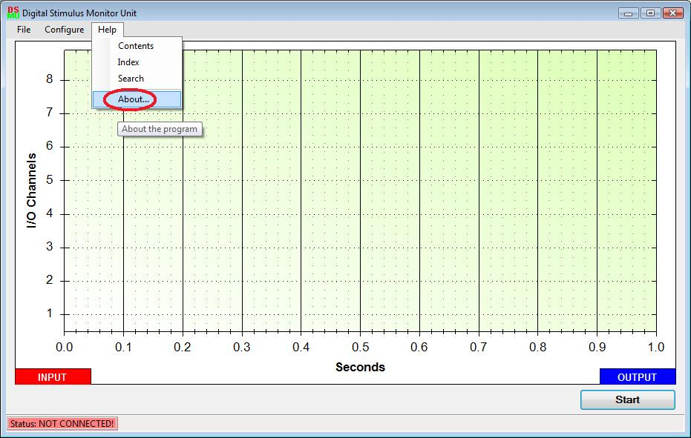
Other features on the Main Window
Main Window Resizing – When the program firsts starts up, it is in its default window size. The main window can be resized to make it bigger by clicking the box-shaped button on the top right corner of the window or by dragging out one of the edges of the window. However, the window cannot be resized to be smaller than its default size.
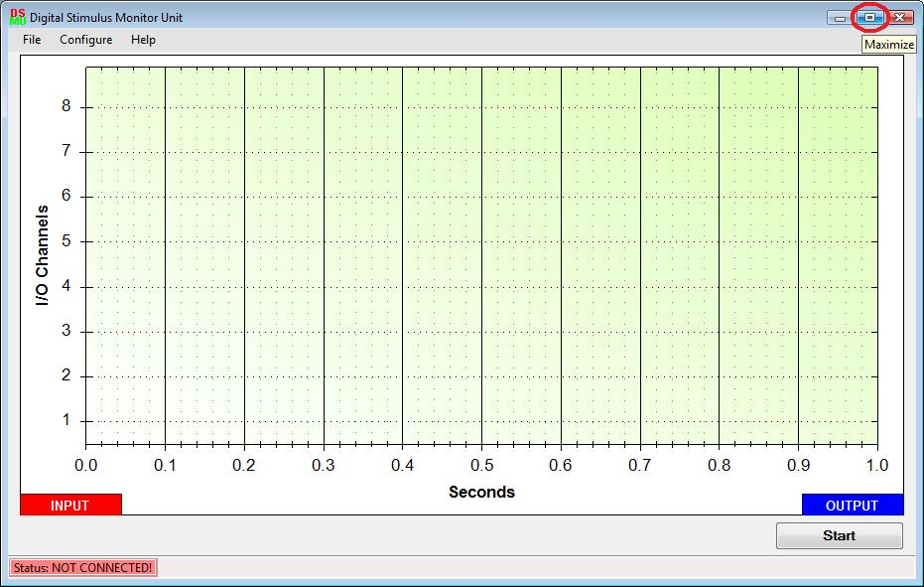

Graph Options – Right clicking on the graph will bring up a drop down box from which the user can select a variety of options. They are as follows –
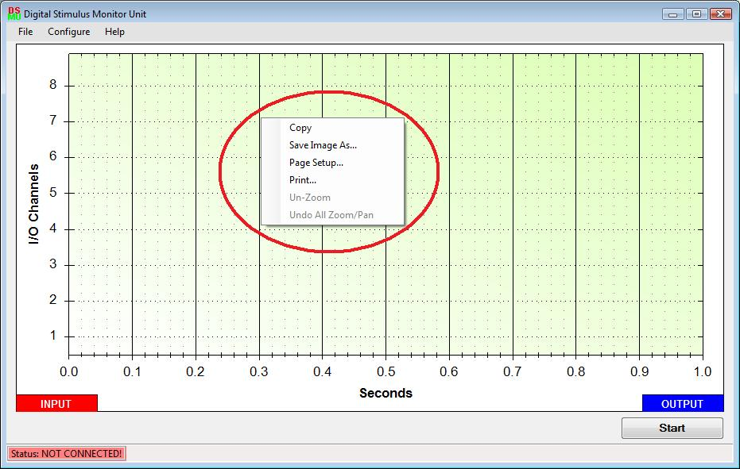

Zoom – This can be accomplished by left clicking and dragging the arrow around an area thus making a rectangular area to zoom into.
Pan – Left clicking on the graph and moving the cursor in any direction will pan the graph in the direction.
Copy – This option can be reached by right clicking on the graph. It enables the user to copy the graph as an image and then paste it into other programs such as Paint, Adobe products, and other graphic software.
Save Image As – This option enables the user to save the current graph as an image file with formats such as .jpg, .bmp, .png etc…
Page Setup – Through this option the user can setup the page layout for the graph, which can then be printed through options in the Page Setup dialog or through the Print option in the main menu. (See Main Menu options for more details).
Print – The user can print the current graph using this option. A print dialog similar to the one obtained by clicking the Print option in the main menu will pop-up. For more details see Main Menu options.
Un- Zoom – This option will un-zoom the graph by a factor of one.
Undo All Zoom/ Pan – Clicking this option will bring the graph back to its original state i.e. without any zoom or pan.
Graph Color Settings – The graph has been configured to denote input data channel values in the color blue, and output data channel values in red by default. However, each of these colors can be changed by the user to his/ her preference. This can be done by clicking on either the Input button on the bottom left of the main window or the Output button on the bottom right of the main window to change the input and output data colors respectively.
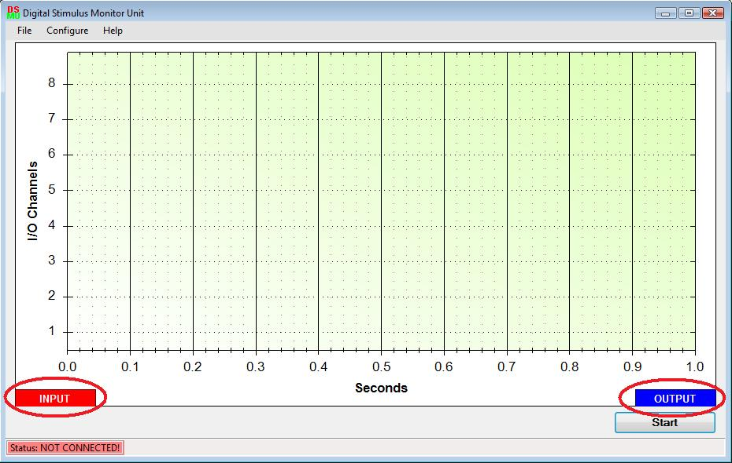

The Start/ Stop Button – This button is located on the bottom right corner of the main window. Clicking this button will enable the DSMU to start sending collected data from its externally connected circuit to the graph screen in the main program window on the PC. The user can stop this process at any time by clicking the same button which will now be labeled Stop. After the process stops the button will be back to its default label of Start.
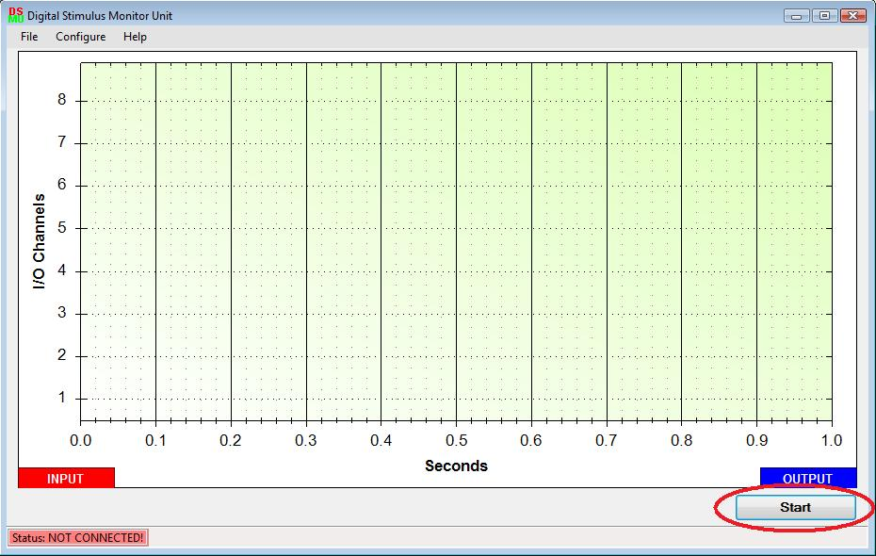
The Status Bar – the Status Bar is located at the very bottom edge of the main window. It has two indicators present: -
Device Connection Status – This is the left most feature on the Status Bar which shows the connection status of the DSMU hardware unit to the PC. It will display “Device Status: NOT CONNECTED” if the DSMU hardware unit is not connected and “Device Status: CONNECTED!” if the unit is connected. The data collection process of the program will not function unless the DSMU hardware unit is connected to the PC.
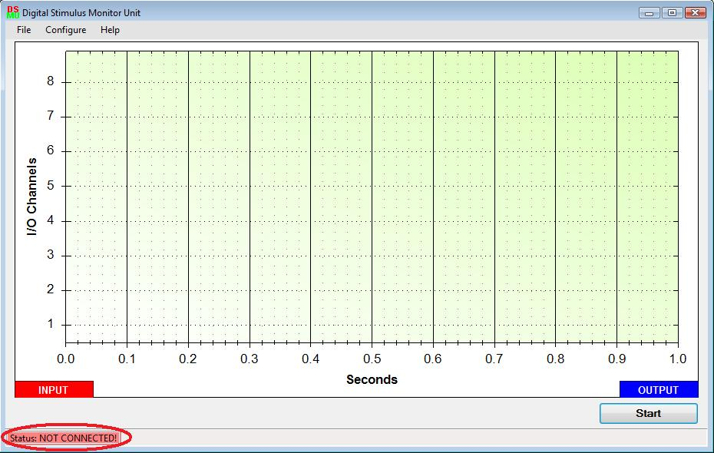

The I/O Direction Control Window
Through this window the user can select the channel directions for the 8 channels of the DSMU hardware unit. The user has to pick from three options for each channel – input, complex output and clocked output. After making the necessary selection, the new configuration is saved to the DSMU unit after the user click the OK button on the bottom left corner of this window. Clicking the Cancel button will render all these changes unsaved. By default, all channels are set to input mode. All eight channels of the DSMU can be selected to be Input Channels. Only the first four channels can be selected as Clocked Output Channels and all eight can be selected as Complex Output Channels. The user can get to this window by clicking the I/O Channels option under the Configure menu item, details of which have been mentioned previously.

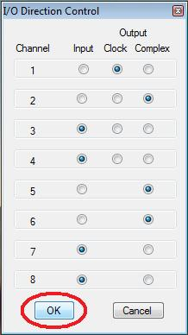

The Complex Output Data Window

Through this window the user can configure complex data signals to send out through the DSMU ports to an externally connected device. The drop-down box in the window will enable the user to select the channel to configure. (NOTE: Only those channels that have been configured as Complex Output Data Channels in the I/O Direction Control Window will be displayed in this drop-down box). Once a particular channel is selected the user can then select the length of the bit-stream to output using the second drop-down box. For this drop-down box, the user has an option to select from 1, 8, 16, 64 etc… pre-chosen values. Lastly, the user needs to enter a bit-stream consisting of only 1’s and 0’s into the text box to send out as complex data. The two labels just beneath the text box show the user the number of bits currently type in the text box and the number of remaining bits (calculated depending on the value selected form the drop- down box earlier). Once each of the above items is configured, the user can click the OK button to save this configuration and send it to the DSMU hardware unit. Clicking Cancel will result in the changed configuration being discarded. The user can repeat these steps to configure bit-streams for each of the ComplexOutput Data Channels as selected from the I/O Direction Control Window.

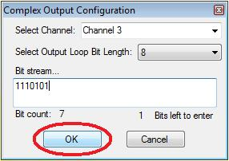

The Clocked Output Data Window
Through this window the user can configure clocked output signals to send out through the DSMU ports to an externally connected device. The drop-down box in the window will enable the user to select the channel to configure. (NOTE: Only those channels that have been configured as Complex Output Data Channels in the I/O Direction Control Window will be displayed in this drop-down box). Once a particular channel is selected the user can then select the frequency of the clocked signal to output through the DSMU ports. Once the channel and frequency is configured, the user can click the OK button to save this configuration and send it to the DSMU hardware unit. Clicking Cancel will result in the changed configuration being discarded. The user can repeat these steps to configure frequencies for each of the ClockedOutput Data Channels as selected from the I/O Direction Control Window.

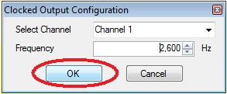

-HARDWARE USER GUIDE
1- Connect the Digital Stimulus Monitor Unit to an available USB 2.0 port on a host PC.
2- Before connecting any test circuits to the Digital Stimulus Monitor Unit, please make sure you have already performed the steps listed in the software user manual to install the necessary drivers.
3- Connect the test circuits to the eight input/output ports located on the Digital Stimulus Monitor Unit device and perform the necessary software configurations in the GUI (refer to the software user manual)
4- The data direction is set to input (green) on default, as soon as the data direction is changed in the GUI, the data direction LED will change to reflect the current direction. Output LEDs are red and input LEDs are green.
5- When done using the Digital Stimulus Monitor Unit, simply disconnect the USB cable.
Warning: Do not disconnect the USB cable anytime during operation on the Digital Stimulus Monitor Unit to prevent data loss.

