This is further information for SP a 7

This is for the testbench that applies tests to the ALU version that has input registers and an output bus driver. It also generates flags.

The code for the testbench is in file tbalu3.vhdl

The testbench runs a bus cycle on the input busses. The only way to load values into the ALU input registers is for the testbench to load them. The following shows the timing on the busses.

In the testbench code in tbalu3.vhdl this buy cycle is run through a procedure declared in the declarative region of the process. Then to run a bus cycle the user simply call the procedure buscycle with the appropriate parameters

Procedure buscycle has the following parameters

Procedure buscycle (
(abusop,bubusop : busoptype
Busoptype can have a value of
idle : The bus is highz
drva : A bus driven from registers
drvb : B bus driven from registers
tbdra : testbench drives the A BUS
tbdrb : testbench drives the B BUS
Abusval,bbusval : std_logic_vector (15 downto 0)
These are values that are needed when the value of the bus comes
from the testbench
aluinctl : aluctlintyp
has values of
idle : Load no values this bus cycle
ltca : Load ABUS into A input register
ltcb : Load BBUS into B input register
ltcab : Load both A and B input register from respective busses
oper – the value to assign to control signal op - 4 entry std_logic_vector
abus_v
Cin_v the last 4 are the std_logic value of the signals
s_v
dr_v)

This makes it very easy to write the tests. They will look something like this

buscycle (tbdra,tbdrb,i0,i0,ltcab,opand,'0','0','0','1');
buscycle (tbdra,tbdrb,i0,i1,ltca,opand,'0','0','0','1');
buscycle (tbdra,tbdrb,i0,i2,ltcb,opor,'0','0','0','1');
buscycle (tbdra,tbdrb,i0,i3,idle,opor,'0','0','0','1');

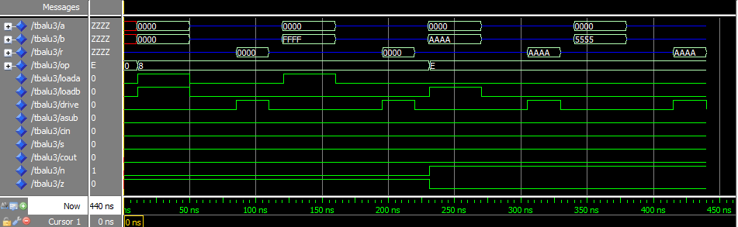

Simply write tests here to do a better job of testing your alu design.

