SP a 1: Semester Project assignment 1

This is the first step in the semester project. The project is the design of the arithmetic logic unit for the model of the microcontroller. There are two possible approaches to it. The first is a brute force approach where you have units to do each operation and then multiplex the correct one out.

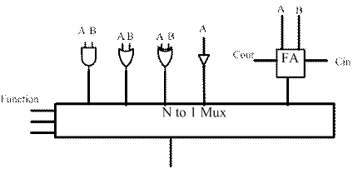

The second approach is to have a unit to do logic operations and an efficient adder for addition and subtraction. Note that these are 16 bit operational units.
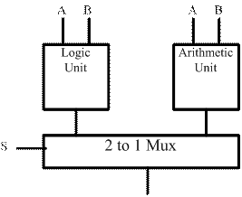

In the second alternative, the adder design should be efficient. There are several alternatives:
Base line – ripple carry adder – a sequence of full adders
Carry select adder
Carry lookahead adder
Carry multiplexed adder

This assignment is to write a short report of 2 or 3 pages on these adder architectures. The reports should detail briefly the significant feature of the design. It should also highlight on the speed (time to complete the add) and logic required to implement the design. Does the amount of logic grow linearly with the number of bits or does the amount of logic required grow exponentially? Which has the fastest speed? Document you sources and references properly!!

