Assignment : assignment name Example follows for half adder

Name

The VHDL code for this assignment follows:

VHDL code for the half

-- ENTITY and ARCHITECTURE for a half adder
ENTITY ha IS
PORT (a,b : IN bit;
sum,cout : OUT bit);
END ha;

ARCHITECTURE one OF ha IS
BEGIN
sum <= a XOR b;
cout <= (a AND b);
END one;

The testbench for the half adder was provided.

As it so rudimentary the testbench is included here.

-- Testbench for a half adder
-- Adapted from a full adder so a cin signal is available also but not used
ENTITY testha IS
END testha;

ARCHITECTURE one OF testha IS
--Declare component and configure
COMPONENT ha IS
PORT (a,b : IN bit;
sum,cout : OUT bit);
END COMPONENT;
FOR all : ha USE ENTITY work.ha(one);
-- declare signals for stimulus and hookup
SIGNAL a,b,cin,sum,cout : BIT;

BEGIN
-- instantiate component
a1 : ha PORT MAP (a,b,sum,cout);

PROCESS
BEGIN
--WAIT FOR 20 ns;
a <= '0'; b <= '0'; cin<= '0';
WAIT FOR 20 ns;
a <= '0'; b <= '0'; cin<= '1';
WAIT FOR 20 ns;
a <= '0'; b <= '1'; cin<= '0';
WAIT FOR 20 ns;
a <= '0'; b <= '1'; cin<= '1';
WAIT FOR 20 ns;
a <= '1'; b <= '0'; cin<= '0';
WAIT FOR 20 ns;
a <= '1'; b <= '0'; cin<= '1';
WAIT FOR 20 ns;
a <= '1'; b <= '1'; cin<= '0';
WAIT FOR 20 ns;
a <= '1'; b <= '1'; cin<= '1';
WAIT FOR 20 ns;
WAIT;
END PROCESS;
END one;

Files were compiles in ModelSim and then simulated.
The waveform window was undocked and using ctl-alt-PrintScreen on a PC captured and pasted below.

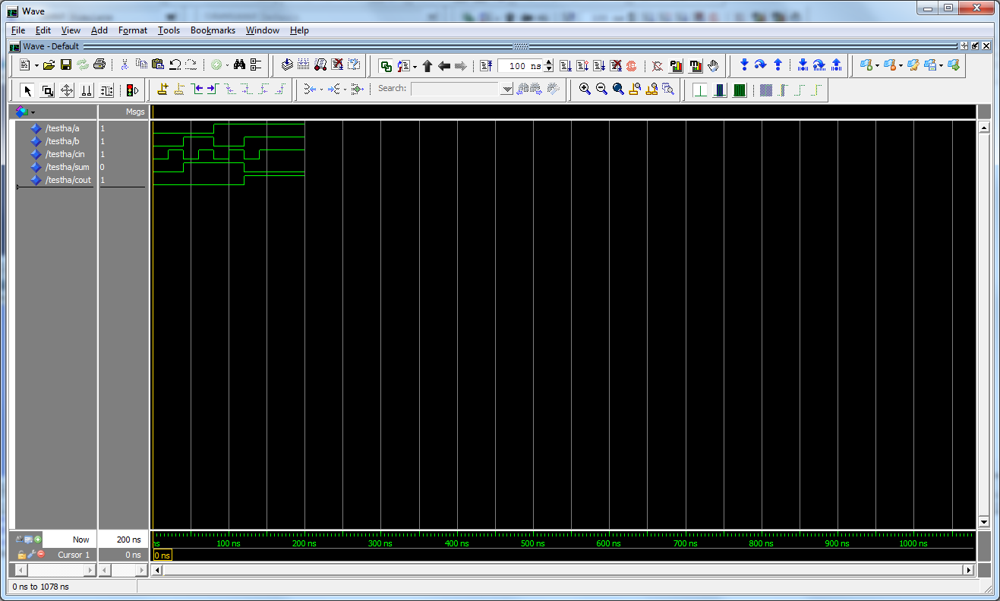

Quartis work:

Quartis was used to synthesize the design. The wizard was used to link the VHDL files.
Synthesis was run and was successful.

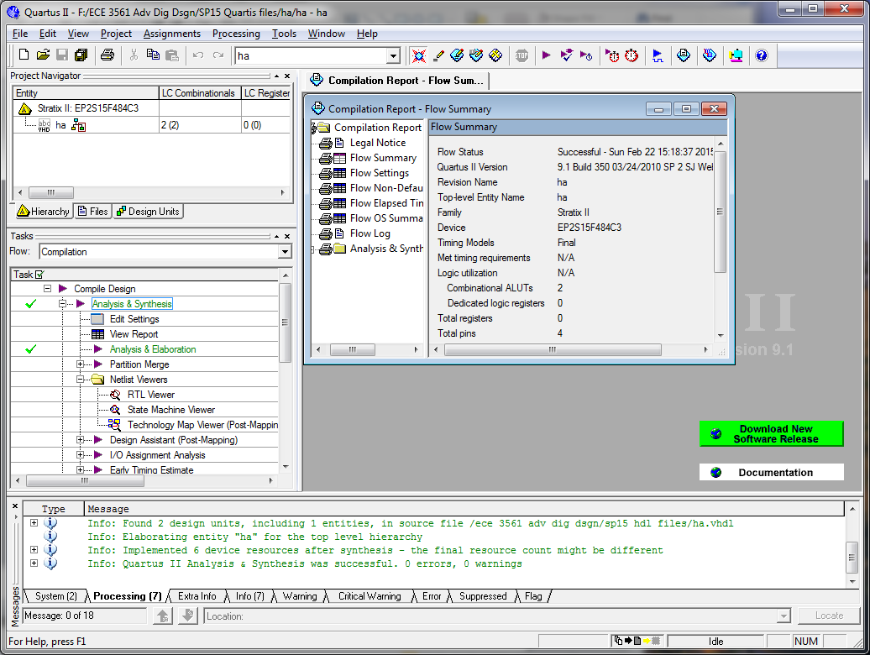

The RTL viewer shows the circuit for the half adder is an OR gate and an AND gate.

