THIS IS AN OPEN BOOK/OPEN NOTES QUIZ – NO ELECTRONIC DEVICES
(10 points)

(8) The A to D converter on the 68HC11 has a control register ADCTL which has bits as shown below. Table 7.1 shows the value of the channel selection bits.
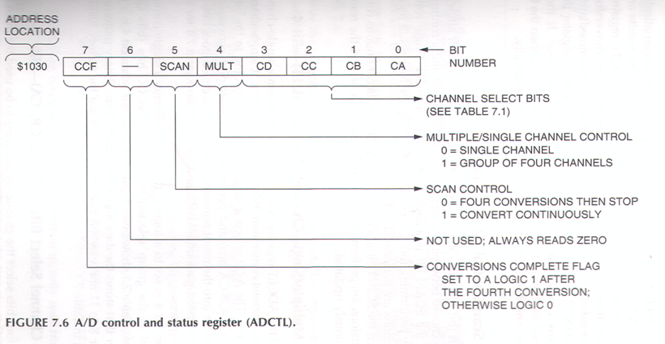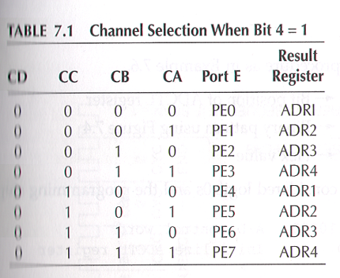

(4) What value needs to be stored to this register to set up the converter to do four conversions on the 4 pins, PE0, PE1, PE2, and PE2 and then do no more conversion until told to do so?

%x x 0 1 0 0 0 0 or HEX $10 or decimal 16

If %0011 0000 or HEX $30 -1point

(6) What assembler language instructions would be need to set up this configuration in the register?
The A accumulator is available for use in doing the configuration.

LDAA #$10 need # (immediate mode) and value from 4
STAA $1030

Store to wrong address -2
No store -3
Load wrong value (not value from 1st part -1
No LDAA -3

