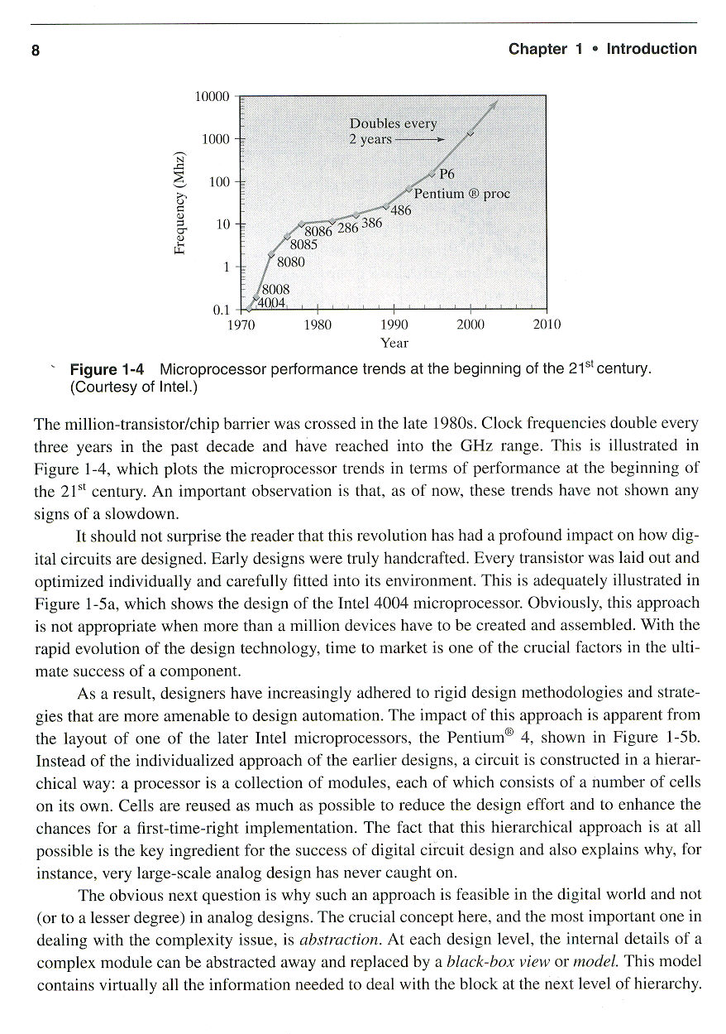

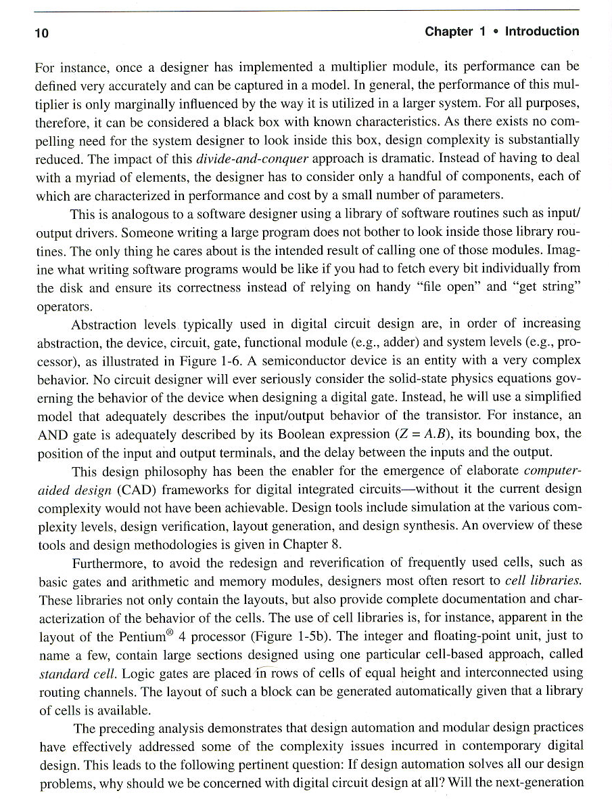
Digital vs. Analog Abstraction Levels

Digital Information Processing Analog Information Processing

Stochastic Signal Detection/Estimation Operations ?

Simple DSP filtering Op amp filtering functions

Multiply and Accumulate and Registers Combine Gilbert Cell + Op amps

Large bitword multipliers Innovative Circuit topologies

Small bitword multipliers Basic Gilbert Cell

Large bitword adders Innovative Op amp topologies

Small bitword adders Various types of Op amp circuits

Single bit adders ?

Latches and Flip/Flops ? some temporary poor storage

Nands, Nors, XORs, Mux Op Amps, Analog Mux

Inverters Op Amps

Function vs. Physical Behavior abstraction Stay in the physical domain

Pull up with pull down transistor circuit behavior Ratio of load/driver transistors

Transistor and Device equations Transistor and Device equations

Figure 1.6 Digital Abstraction Levels

n+
n+
S
G
D
+
DEVICeE
CIRCUItT
GATeE
SYSTEmM

MODULeE

